UK News Website of the Year 2024

* [Celia Walden](https://web.archive.org/web/20250113190727/https:/www.telegraph.co.uk/authors/c/ca-ce/celia-walden/)

**The days of woke bullies and their hate campaigns are coming to an end**

HBO’s backing of JR Rowling shows that if companies stand firm instead of giving into bleating liberal trolls, the mob is rendered powerless

[219](https://web.archive.org/web/20250113190727/https:/www.telegraph.co.uk/news/2024/11/25/hbo-defence-of-jk-rowling-woke-mind-virus-in-retreat/#comment)

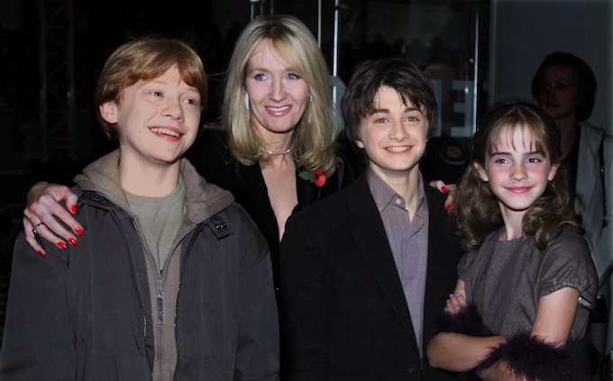

Happier times: Rowling with Rupert Grint, Daniel Radcliffe and Emma Watson at the premiere of the first Harry Potter film in 2001 Credit: Ian Jones

[Celia Walden](https://web.archive.org/web/20250113190727/https:/www.telegraph.co.uk/authors/c/ca-ce/celia-walden/)

25 November 2024 7:00pm GMT



There are two boardroom meetings I fervently wish I could have attended – and that’s not a sentence I ever thought I’d write. The first is the marketing meeting where [Jaguar’s recent rebranding campaign](https://web.archive.org/web/20250113190727/https:/www.telegraph.co.uk/news/2024/11/23/jaguars-rebrand-is-the-latest-attempt-to-subvert-history/) was devised. Because I genuinely want to understand how anyone specialising in [luxury rebrands](https://web.archive.org/web/20250113190727/https:/www.telegraph.co.uk/business/2024/11/22/jaguar-boss-says-criticism-advert-hatred-intolerance/) thought: “Yes! This is how we sell cars”. Who are these delusional air-punchers? And if you haven’t yet seen the “bold” (pronounced “brand imploding”) new “copy nothing” advert featuring no big cats, no suave men and no cars (just a load of androgynous models in citrus polyester telling you to live your wokeist life), prepare to enjoy that short, sharp snort of derision.

The second meeting I would have liked to be present at is the “emergency” PR conference that will have taken place at HBO last week, after a vicious online reaction to the announcement that JK Rowling will be serving as an executive producer on the forthcoming [Harry Potter TV series](https://web.archive.org/web/20250113190727/https:/www.telegraph.co.uk/news/2024/11/22/warner-bros-jk-rowling-transgender-transphobe/). Because no one, you’ll note, is ever as vicious as the “be kind” brigade.

Now, although it’s a given that any company even vaguely affiliated with the author will be subjected to this sort of backlash, it will have taken the powers-that-be a moment to thrash out a statement defending their decision, and the final draft of the American production firm’s statement to *Variety* read: “We are proud to once again tell the story of Harry Potter – the heart-warming books that speak to the power of friendship, resolve and acceptance. JK Rowling has a right to express her personal views. We will remain focused on the development of the new series, which will only benefit from her involvement.”

One of these two companies has understood its target demographic. One of them can also see which way the wind is blowing. And let me give you a clue: it’s not Jaguar. Or, indeed, JaGUar (possibly the most baffling part of the rebrand). I won’t go so far as to talk about convictions, because I’m not convinced any multi-billion pound corporation really has those, but if you’re peddling things to the masses, it’s probably a good idea not to seal yourself off from them. And yes, I know that those virtuous little bubbles hold a particular appeal, but let HBO’s stance and statement serve as a template for exactly how a company should behave in the dying days of 2024.

Instead of basing its entire ethos on the bleatings of a dozen extremely vocal liberals on X, HBO has clearly looked around, listened, and identified a swing of the pendulum. It’s the little things you might want to take note of, you know? Like Donald Trump winning the popular vote, America’s overwhelming rejection of what [Elon Musk calls “the woke mind virus”](https://web.archive.org/web/20250113190727/https:/www.telegraph.co.uk/world-news/2023/09/01/elon-musk-reveals-twitter-takeover-hatred-woke-mind-virus/), World Athletics’ ban on transgender women competing in female world ranking events, and the phasing out of gender-neutral toilets on both sides of the pond.

Seriously, you’d have to be wearing opinion-cancelling earplugs not to have picked up on at least some of this stuff. But, of course, that’s exactly what people in woke echo-chambers are doing. So when the Jaguar rebranders come out with their “brave” rallying cry, there’s an awkward silence before someone is forced to break the news: “I’m so sorry, but you’re five to 10 years late.”

I pulled those numbers out of my head, but they turn out to be eerily accurate. According to research conducted by the peer-reviewed journal *Global Policy*earlier this year, “woke capitalism” in corporate America – as always, leading the charge – began to rise in 2015 and peaked in 2020. Since then, it has seen a decline steep enough to explain HBO’s bullish tone.

Not only is the network “proud” to be working with Rowling the “transphobe”, Rowling the “virulent bigot”, Rowling the “Nazi”, who has the temerity to object to women being called “people who menstruate”, but HBO is prepared to address the [issue of personal “rights” head-on](https://web.archive.org/web/20250113190727/https:/www.telegraph.co.uk/columnists/2024/01/17/jk-rowling-strike-transgender-statesman/). It is going to bring it back to freedom of speech and democracy, before stressing once again how honoured it is to be working with the author.

You know what happens when companies do this? When instead of giving into cowardice and the online trolls they double down on their initial decision and back themselves? They [render the mob powerless](https://web.archive.org/web/20250113190727/https:/www.telegraph.co.uk/business/2023/04/15/jk-rowling-transgender-views-uncancelled/). Immediately. It’s like a switch. People can carry on trying to mount their little hate campaigns online, and they will – “if you are a good human being, you cannot watch this show!” – but it won’t make a dent.

Millions will watch the HBO series, millions will remember why they loved Rowling to begin with, and other, smaller companies will understand that they, too, can stand up to woke bullies. Everyone’s a winner. Except JaGUar, of course.

<https://www.telegraph.co.uk/news/2024/11/25/hbo-defence-of-jk-rowling-woke-mind-virus-in-retreat/>   
  
  
Actors-wrongdoers: woke bullies

Actors-victims: JK Rowling

Actors-problem solvers: production firm???